**Assignment -1**

Python Programming

|  |  |
| --- | --- |
| Assignment Date |  |
| Student Name | GUNDLAPALLI CHIDVILAS |
| Student Roll Number | 111519104040 |
| Maximum Marks |  |

**Question 1:**

**Import the necessary libraries**

**Solution:**

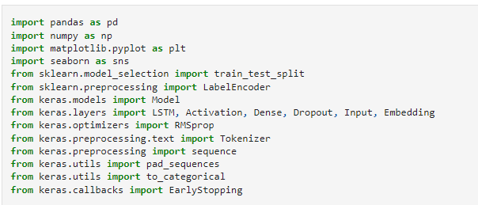

**Question 2:**

**Download the Dataset**

**Solution:**

Dataset Downloaded and uploaded to drive <https://www.kaggle.com/code/kredy10/simple-lstm-for-text-classification/data>

**Question 3:**

**Read dataset and do pre-processing**

**Solution:**

Read dataset

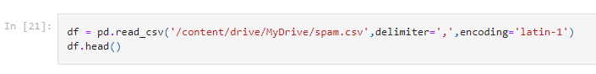

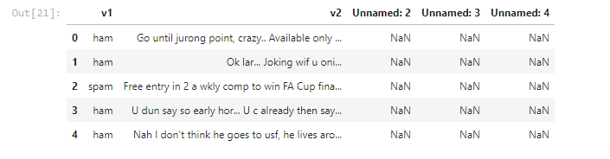

Pre-processing the Dataset

